Abstraction

📌 Definition:
# Source: AI Source: Provided by: [Data Path: Persons Table -> ID Column: 1, Name_En Column: Motasem Essam] -> From: [ChatGPT] on [12/9/2025]
Abstraction is an OOP principle that hides complex implementation details and shows only the essential features of an object.

🧠 Simple idea:
# Source: AI Source: Provided by: [Data Path: Persons Table -> ID Column: 1, Name_En Column: Motasem Essam] -> From: [ChatGPT] on [12/9/2025]
Abstraction = “What to do, not how to do it” 🎯

🔍 Key characteristics:
# Source: AI Source: Provided by: [Data Path: Persons Table -> ID Column: 1, Name_En Column: Motasem Essam] -> From: [ChatGPT] on [12/9/2025]
- 🔒 Hides internal details
- 👀 Exposes only necessary functionality
- 🧩 Reduces complexity
- ⚙️ Improves code security and maintainability
- 📦 Focuses on essential behavior

📌 Real-world example:
# Source: AI Source: Provided by: [Data Path: Persons Table -> ID Column: 1, Name_En Column: Motasem Essam] -> From: [ChatGPT] on [12/9/2025]
- 🚗 When you drive a car, you use:
  - Steering wheel
  - Accelerator
  - Brake
👉 You don’t need to know how the engine works internally

📌 In programming (Java example):
# Source: AI Source: Provided by: [Data Path: Persons Table -> ID Column: 1, Name_En Column: Motasem Essam] -> From: [ChatGPT] on [12/9/2025]
Using abstract class:
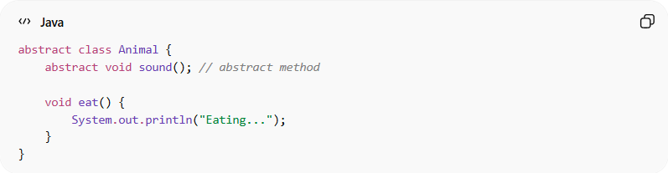
abstract class Animal {
abstract void sound(); // abstract method

void eat() {
System.out.println("Eating...");
}
}

Concrete implementation:
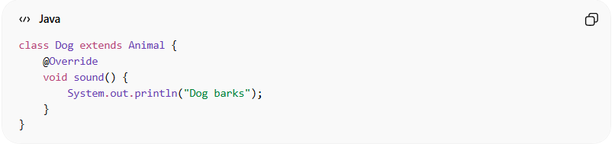
class Dog extends Animal {
@Override
void sound() {
System.out.println("Dog barks");
}
}

Usage:
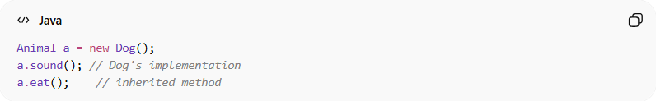
Animal a = new Dog();
a.sound(); // Dog's implementation
a.eat(); // inherited method

⚙️ Ways to achieve abstraction:
# Source: AI Source: Provided by: [Data Path: Persons Table -> ID Column: 1, Name_En Column: Motasem Essam] -> From: [ChatGPT] on [12/9/2025]
- 📌 Abstract classes
- 📌 Interfaces

🆚 What abstraction hides:
# Source: AI Source: Provided by: [Data Path: Persons Table -> ID Column: 1, Name_En Column: Motasem Essam] -> From: [ChatGPT] on [12/9/2025]
- ❌ Internal logic
- ❌ Implementation details
- ❌ Complex processes

🎯 What abstraction shows:
# Source: AI Source: Provided by: [Data Path: Persons Table -> ID Column: 1, Name_En Column: Motasem Essam] -> From: [ChatGPT] on [12/9/2025]
- ✔️ Only important methods
- ✔️ Clean and simple interface
- ✔️ What the object can do

🎯 Why it is important:
# Source: AI Source: Provided by: [Data Path: Persons Table -> ID Column: 1, Name_En Column: Motasem Essam] -> From: [ChatGPT] on [12/9/2025]
- 🧩 Simplifies complex systems
- 🔄 Improves reusability
- 🧠 Makes code easier to understand
- 🔒 Enhances security

🎯 Summary:
# Source: AI Source: Provided by: [Data Path: Persons Table -> ID Column: 1, Name_En Column: Motasem Essam] -> From: [ChatGPT] on [12/9/2025]
Abstraction hides unnecessary details and exposes only the essential features, allowing users to interact with objects without knowing their internal complexity.

